Month
# Source: AI Source: Provided by: [Data Path: Persons Table -> ID Column: 1, Name_En Column: Motasem Essam] -> From: [ChatGPT] on [7/17/2026]
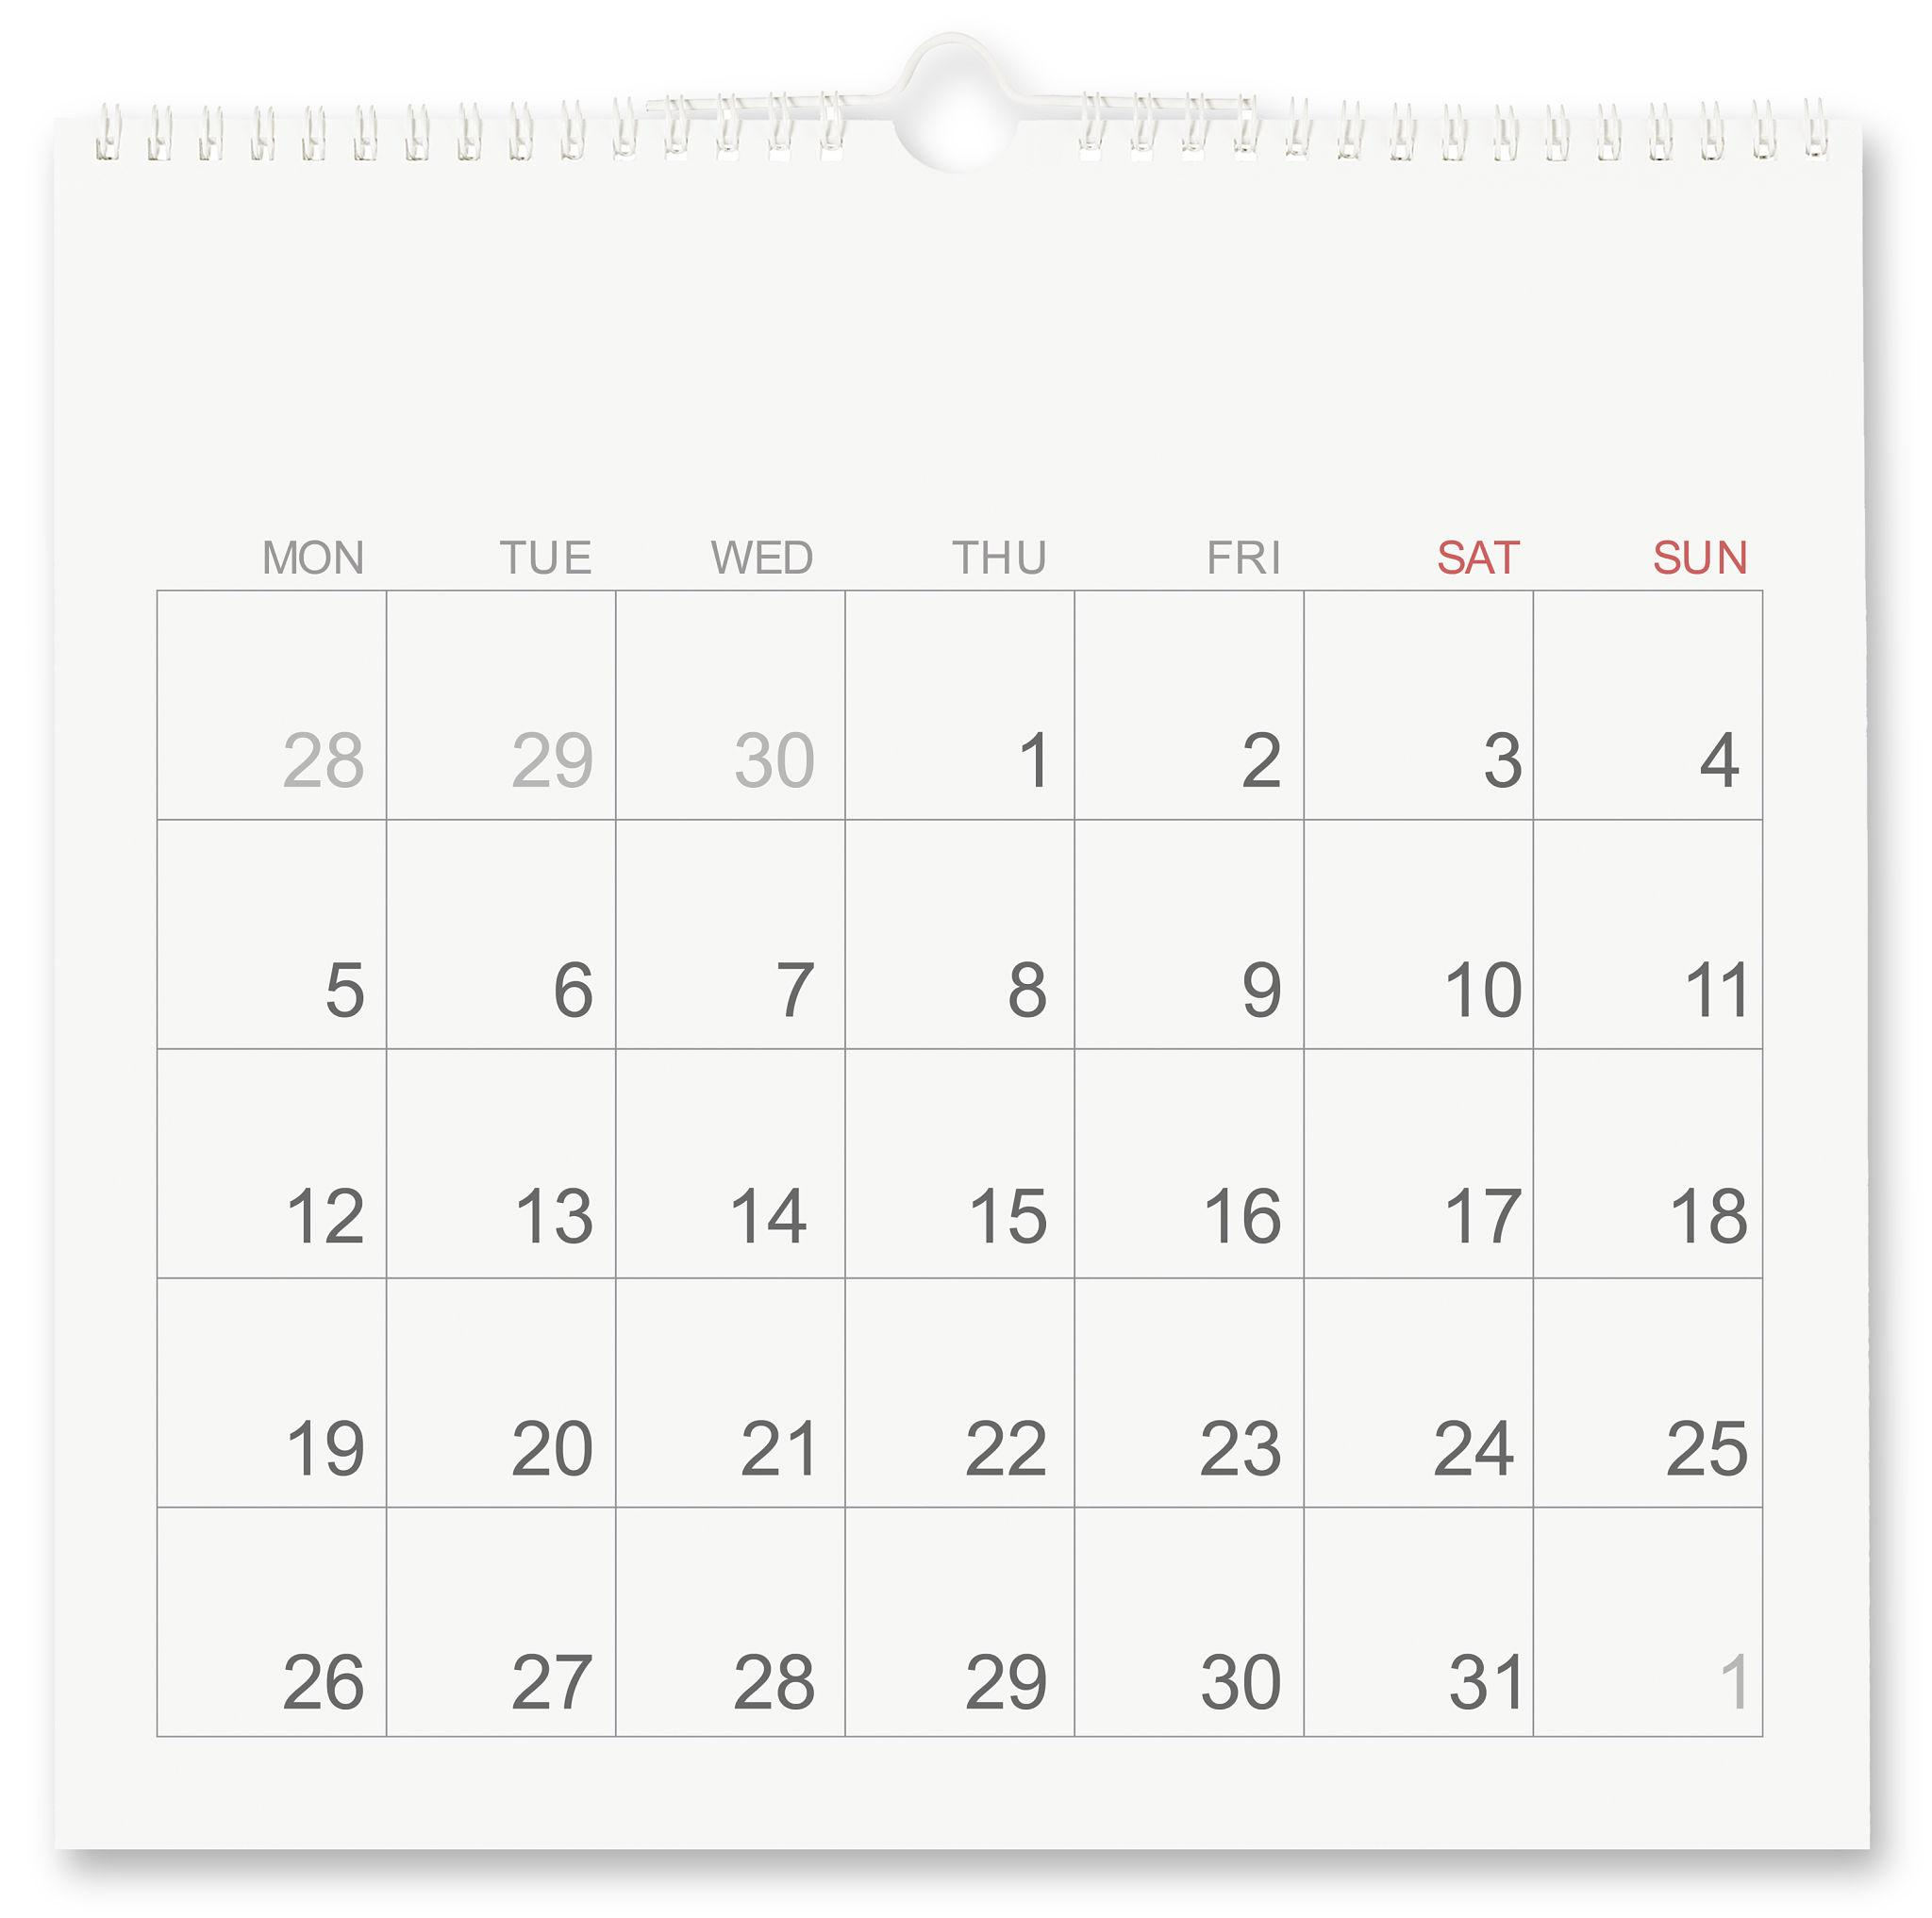
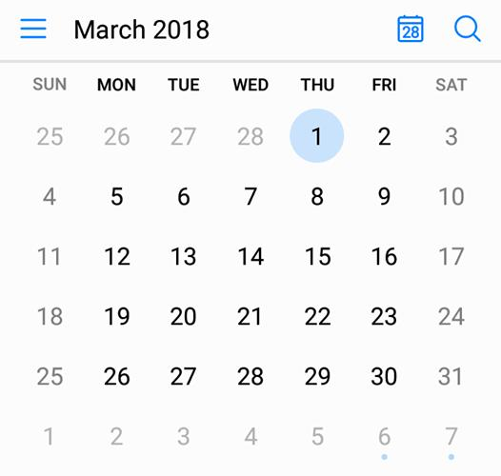
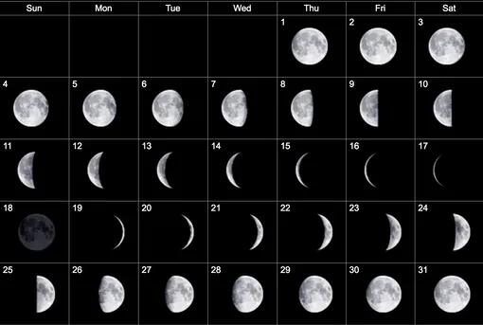

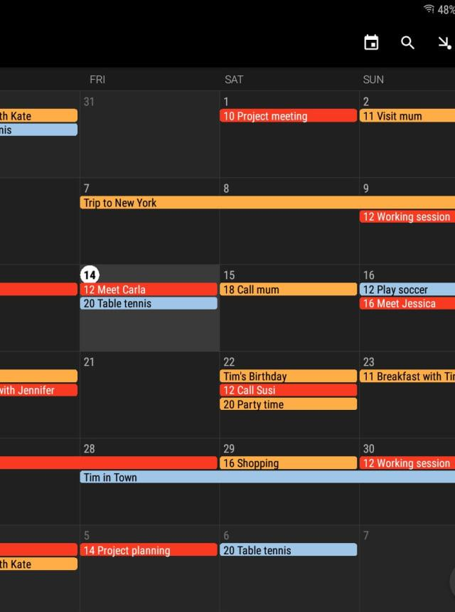
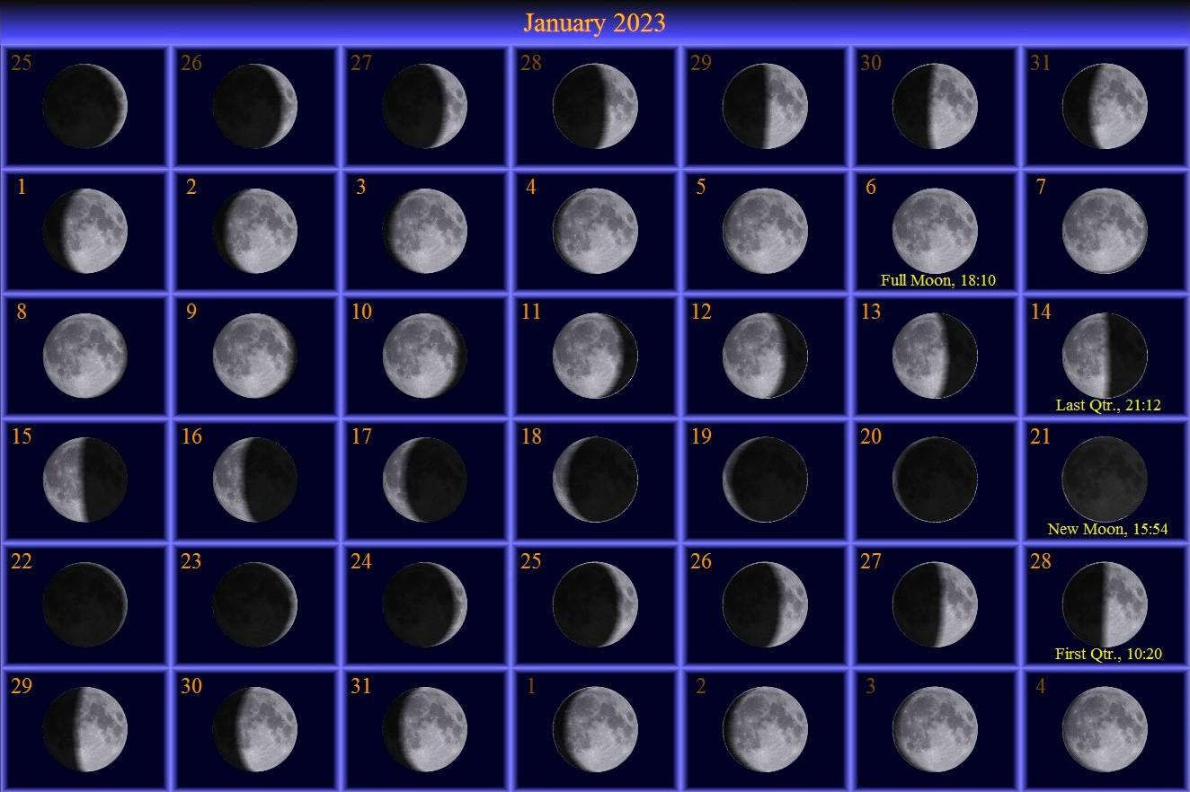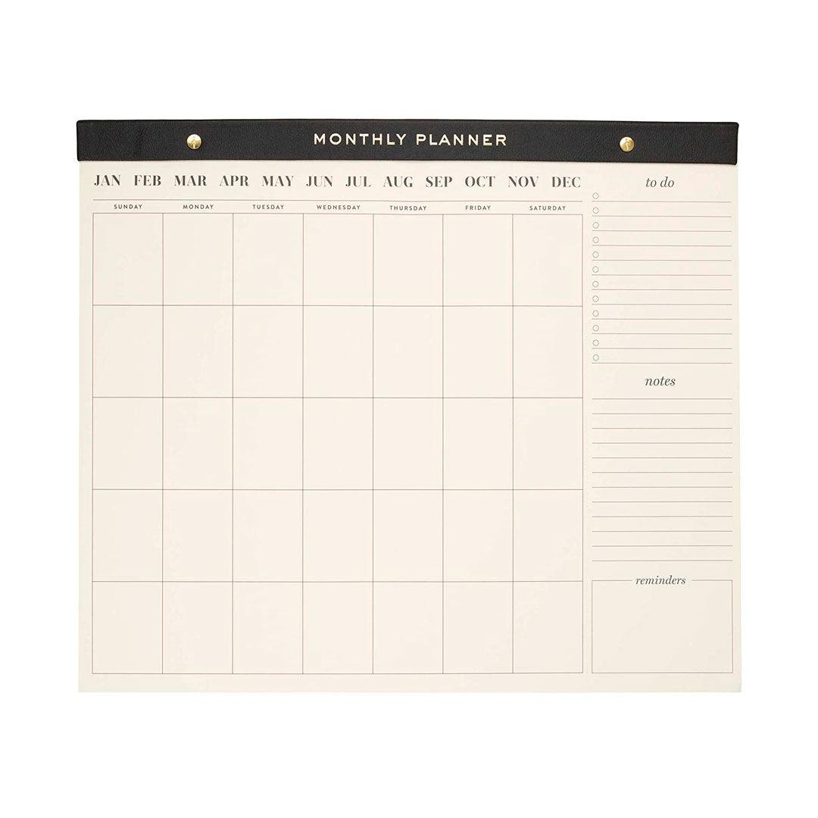
A Month is a unit of time that divides a year into smaller periods. Historically, the concept of a month originated from the lunar cycle, which is the time it takes the Moon to complete one cycle of phases. In modern civil calendars, such as the Gregorian Calendar, months have fixed lengths ranging from 28 to 31 days.

Definition
# Source: AI Source: Provided by: [Data Path: Persons Table -> ID Column: 1, Name_En Column: Motasem Essam] -> From: [ChatGPT] on [7/17/2026]
A Month is a unit of time that divides a year into twelve parts. In modern calendars, a month contains between 28 and 31 days.

Origin of the Month
# Source: AI Source: Provided by: [Data Path: Persons Table -> ID Column: 1, Name_En Column: Motasem Essam] -> From: [ChatGPT] on [7/17/2026]
The word month comes from the word Moon because early calendars measured time using the Moon's phases.
One complete lunar cycle (synodic month) lasts approximately:
$$29.5306\text{ days}$$
This natural cycle inspired the creation of months in many ancient calendars.

Length of a Month
# Source: AI Source: Provided by: [Data Path: Persons Table -> ID Column: 1, Name_En Column: Motasem Essam] -> From: [ChatGPT] on [7/17/2026]
In the Gregorian Calendar, months contain:
- 28 days (February in a common year)
- 29 days (February in a leap year)
- 30 days
- 31 days

Months of the Gregorian Calendar
# Source: AI Source: Provided by: [Data Path: Persons Table -> ID Column: 1, Name_En Column: Motasem Essam] -> From: [ChatGPT] on [7/17/2026]
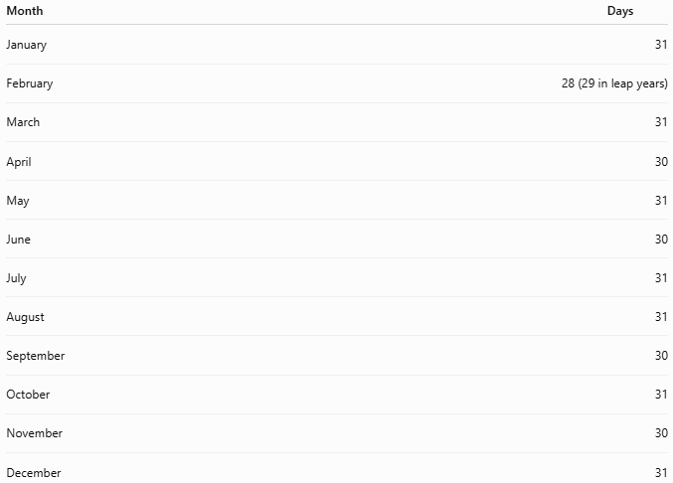
Month | Days
January | 31
February | 28 (29 in leap years)
March | 31
April | 30
May | 31
June | 30
July | 31
August | 31
September | 30
October | 31
November | 30
December | 31

Total Number of Months
# Source: AI Source: Provided by: [Data Path: Persons Table -> ID Column: 1, Name_En Column: Motasem Essam] -> From: [ChatGPT] on [7/17/2026]
One year contains:
- 12 months

Relationship to Other Time Units
# Source: AI Source: Provided by: [Data Path: Persons Table -> ID Column: 1, Name_En Column: Motasem Essam] -> From: [ChatGPT] on [7/17/2026]
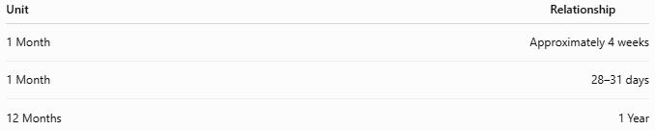
Unit | Relationship
1 Month | Approximately 4 weeks
1 Month | 28–31 days
12 Months | 1 Year

Types of Months

1. Calendar Month
# Source: AI Source: Provided by: [Data Path: Persons Table -> ID Column: 1, Name_En Column: Motasem Essam] -> From: [ChatGPT] on [7/17/2026]
A month defined by a calendar.
Examples:
- January
- June
- October

2. Lunar Month
# Source: AI Source: Provided by: [Data Path: Persons Table -> ID Column: 1, Name_En Column: Motasem Essam] -> From: [ChatGPT] on [7/17/2026]
A month based on the Moon's phases.
Average length:
$$29.5306\text{ days}$$
Used in:
- Islamic Calendar
- Hebrew Calendar
- Chinese Calendar
- Traditional Hindu Calendars

3. Solar Month
# Source: AI Source: Provided by: [Data Path: Persons Table -> ID Column: 1, Name_En Column: Motasem Essam] -> From: [ChatGPT] on [7/17/2026]
A month based on the Earth's position relative to the Sun.
Used in some solar calendar systems, such as the Persian (Solar Hijri) Calendar.

Applications
# Source: AI Source: Provided by: [Data Path: Persons Table -> ID Column: 1, Name_En Column: Motasem Essam] -> From: [ChatGPT] on [7/17/2026]
Months are used in:
- Calendars
- School schedules
- Business reporting
- Financial statements
- Weather records
- Agriculture
- Birthdays and anniversaries
- Government planning

Financial Use
# Source: AI Source: Provided by: [Data Path: Persons Table -> ID Column: 1, Name_En Column: Motasem Essam] -> From: [ChatGPT] on [7/17/2026]
Many financial activities are organized monthly, including:
- Salaries
- Utility bills
- Bank statements
- Budgets
- Loan payments

Scientific Use
# Source: AI Source: Provided by: [Data Path: Persons Table -> ID Column: 1, Name_En Column: Motasem Essam] -> From: [ChatGPT] on [7/17/2026]
Scientists use months for:
- Climate observations
- Population studies
- Seasonal analysis
- Environmental monitoring

Advantages
# Source: AI Source: Provided by: [Data Path: Persons Table -> ID Column: 1, Name_En Column: Motasem Essam] -> From: [ChatGPT] on [7/17/2026]
Using months allows people to:
- Divide the year into manageable periods.
- Plan long-term activities.
- Organize schedules.
- Track seasonal changes.
- Record historical events.

Common Mistakes
# Source: AI Source: Provided by: [Data Path: Persons Table -> ID Column: 1, Name_En Column: Motasem Essam] -> From: [ChatGPT] on [7/17/2026]
- Assuming every month contains exactly 30 days.
- Forgetting that February has 28 or 29 days.
- Confusing calendar months with lunar months.
- Assuming every month has exactly 4 weeks (most months are slightly longer).

Interesting Facts
# Source: AI Source: Provided by: [Data Path: Persons Table -> ID Column: 1, Name_En Column: Motasem Essam] -> From: [ChatGPT] on [7/17/2026]
- The Gregorian Calendar has 365 days distributed across 12 months.
- The names of many months come from:
  - Roman gods
  - Emperors
  - Latin numbers
- February is the shortest month of the year.

Key Points
# Source: AI Source: Provided by: [Data Path: Persons Table -> ID Column: 1, Name_En Column: Motasem Essam] -> From: [ChatGPT] on [7/17/2026]
- A Month divides a year into 12 parts.
- Gregorian months contain:
  - 28–31 days
- Lunar months average:
$$29.5306\text{ days}$$
- Months are widely used in calendars, finance, education, science, and daily life.
- Different calendar systems define months differently, but all use them as major units of time.

Conclusion
# Source: AI Source: Provided by: [Data Path: Persons Table -> ID Column: 1, Name_En Column: Motasem Essam] -> From: [ChatGPT] on [7/17/2026]
A Month is one of the principal units of time used to organize the year. Originating from the Moon's natural cycle, the concept has evolved into the fixed calendar months used today. In the Gregorian Calendar, the year is divided into 12 months of varying lengths, providing a practical framework for scheduling, planning, finance, education, and everyday life. While modern calendar months are fixed, many traditional calendar systems continue to base their months on the lunar cycle, preserving the historical connection between the Moon and the measurement of time.

